C Program for STACK Using Arrays

#include<stdio.h>

int stack[100],choice,n,top,x,i;

void push(void);

void pop(void);

void display(void);

int main()

{

//clrscr();

top=-1;

printf("\n Enter the size of STACK[MAX=100]:");

scanf("%d",&n);

printf("\n\t STACK OPERATIONS USING ARRAY");

printf("\n\t--------------------------------");

printf("\n\t 1.PUSH\n\t 2.POP\n\t 3.DISPLAY\n\t 4.EXIT");

do

{

printf("\n Enter the Choice:");

scanf("%d",&choice);

switch(choice)

{

case 1:

{

push();

break;

}

case 2:

{

pop();

break;

}

case 3:

{

display();

break;

}

case 4:

{

printf("\n\t EXIT POINT ");

break;

}

default:

{

printf ("\n\t Please Enter a Valid Choice(1/2/3/4)");

}

}

}

while(choice!=4);

return 0;

}

void push()

{

if(top>=n-1)

{

printf("\n\tSTACK is over flow");

}

else

{

printf(" Enter a value to be pushed:");

scanf("%d",&x);

top++;

stack[top]=x;

}

}

void pop()

{

if(top<=-1)

{

printf("\n\t Stack is under flow");

}

else

{

printf("\n\t The popped elements is %d",stack[top]);

top--;

}

}

void display()

{

if(top>=0)

{

printf("\n The elements in STACK \n");

for(i=top; i>=0; i--)

printf("\n%d",stack[i]);

printf("\n Press Next Choice");

}

else

{

printf("\n The STACK is empty");

}

}

Copy

OUTPUT:

Enter the size of STACK[MAX=100]:10

STACK OPERATIONS USING ARRAY

--------------------------------

1.PUSH

2.POP

3.DISPLAY

4.EXIT

Enter the Choice:1

Enter a value to be pushed:12

Enter the Choice:1

Enter a value to be pushed:24

Enter the Choice:1

Enter a value to be pushed:98

Enter the Choice:3

The elements in STACK

98

24

12

Press Next Choice

Enter the Choice:2

The popped elements is 98

Enter the Choice:3

The elements in STACK

24

12

Press Next Choice

Enter the Choice:4

EXIT POINT

# C program to insert an element in an array

#include <stdio.h>  
   
int main()  
{  
   int array[100], position, c, n, value;

   printf("Enter number of elements in array**\n**");  
   scanf("%d", &n);  
   
   printf("Enter %d elements**\n**", n);  
   
   for (c = 0; c < n; c++)  
      scanf("%d", &array[c]);  
   
   printf("Enter the location where you wish to insert an element**\n**");  
   scanf("%d", &position);  
   
   printf("Enter the value to insert**\n**");  
   scanf("%d", &value);  
   
   for (c = n - 1; c >= position - 1; c--)  
      array[c+1] = array[c];  
   
   array[position-1] = value;  
   
   printf("Resultant array is**\n**");  
   
   for (c = 0; c <= n; c++)  
      printf("%d**\n**", array[c]);  
   
   return 0;  
}

Output of program:  
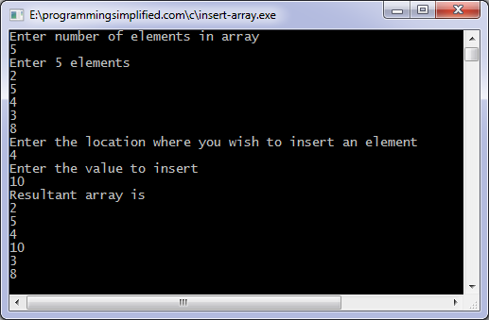

# **C program to delete an element from an array**

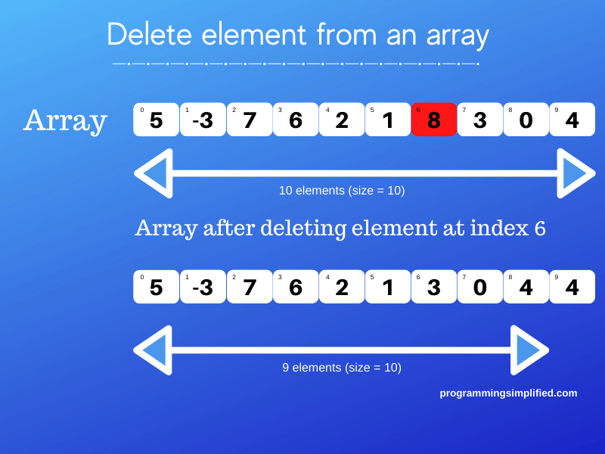

#include <stdio.h>

int main()  
{  
   int array[100], position, c, n;

   printf("Enter number of elements in array**\n**");  
   scanf("%d", &n);

   printf("Enter %d elements**\n**", n);

   for (c = 0; c < n; c++)  
      scanf("%d", &array[c]);

   printf("Enter the location where you wish to delete element**\n**");  
   scanf("%d", &position);

   if (position >= n+1)  
      printf("Deletion not possible.**\n**");  
   else  
   {  
      for (c = position - 1; c < n - 1; c++)  
         array[c] = array[c+1];

      printf("Resultant array:**\n**");

      for (c = 0; c < n - 1; c++)  
         printf("%d**\n**", array[c]);  
   }

   return 0;  
}

C program to delete element from array output:

